**Deadlines:**

For all Groups: October 18 2021

**Grading system:**

- 1 problem - 6

- 2 problems - 7

- 3 problems - 8

- 4 problems - 9

- 5 problems and bonus– 10

**1. Subsets**

Given an integer array set of **unique** elements, return *all possible subsets (the power set)*.

Return the solution in **any order**.

**Example 1:**

**Input:** set = [1,2,3]

**Output:** [[],[1],[2],[1,2],[3],[1,3],[2,3],[1,2,3]]

**Example 2:**

**Input:** set = [0]

**Output:** [[],[0]]

**2. XNOR**

Create a program that would ask for two boolean values (true or false, 0 or 1) and would output the result for the XNOR operation performed on them.

You're allowed to use only `and`, `or` and `not` operations.

**3. Regular Expression Matching**

Given an input string **string** and a pattern **pattern**, implement regular expression matching with support for **’ . ’** and **’ * ’** where:

* **‘ - ‘** Matches any single character.​​​​
* **‘ * ‘** Matches zero or more of the preceding element.

The matching should cover the **entire** input string (not partial).

**Example 1:**

**Input:** string = "aa", pattern = "a"

**Output:** false

**Explanation:** "a" does not match the entire string "aa".

**Example 2:**

**Input:** string = "aa", pattern = "a*"

**Output:** true

**Explanation:** '*' means zero or more of the preceding element, 'a'. Therefore, by repeating 'a' once, it becomes "aa".

**Example 3:**

**Input:** string = "ab", pattern = ".*"

**Output:** true

**Explanation:** ".*" means "zero or more (*) of any character (.)".

**Example 4:**

**Input:** string = "aab", pattern = "c*a*b"

**Output:** true

**Explanation:** c can be repeated 0 times, a can be repeated 1 time. Therefore, it matches "aab".

**Example 5:**

**Input:** string = "mississippi", pattern = "mis*is*p*."

**Output:** false

**4. Truth table solver**

You have to write a program that computes the truth table for various expressions. The set of expressions are limited to:

- `and` operation

- `or` operation

- `not` operation

- supports parenthesis

An example of your program input is `(!x + y) * z + (!z * y * k)` and it should print out:

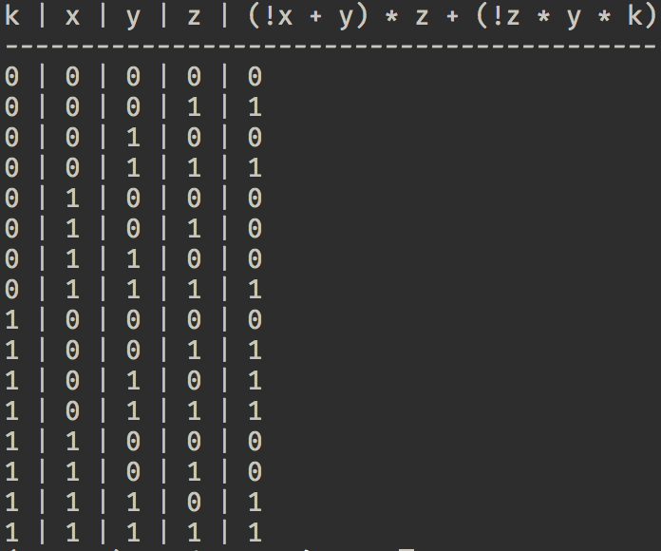

Here are some examples of input that your program should support

```

x + y

!x * y

(!x + y) * x + y * !k

```

**Note:**

I strongly recommend to use the python **`eval`** function. Inventing math operations and their execution priority is **not** the aim of this exercise.

**5. Leibniz harmonic triangle**

Write a program that prints the harmonic triangle for the depth `n`, where `n` is an input value.

**Tip:**

If you're using Python you might look into **`fractions`** module.

## **Bonus: A game of life foreplay** (aka [[Elementary cellular automaton](https://en.wikipedia.org/wiki/Elementary_cellular_automaton)]

In this problem we're going to take a look at elementary cellular automaton. Every cell is like a small micro organism with a few primitive rules. When combining with other cells they form interesting patterns. There also is an interesting ([ted talk](https://www.youtube.com/watch?v=60P7717-XOQ)) given by Stephen Wolfram that touches on this topic.

Your task is to randomly generate a list (let's say of length 200, it's up to you in the end, just make sure to be long enough) containing only the numbers `0` and `1`. Then you start iterating over the list in order to compute the *next generation*. The rules that apply for the next generation are the following.

| 111 | 110 | 101 | 100 | 011 | 010 | 001 | 000 |
| --- | --- | --- | --- | --- | --- | --- | --- |
| 0 | 1 | 1 | 0 | 1 | 1 | 1 | 0 |

For instance if the cells `1`, `2` and `3` have the value `1 1 0` the 2nd cell of the next generation will be `1`.

**PRO Tip:**

READ THIS LINK:<https://natureofcode.com/book/chapter-7-cellular-automata/>

###### **Note:**

For computing the first and the last cell you can consider the missing parent to be `0`.

Now you have to compute the next 100 generations and print the resulting matrix with color for value `1` and with white for value `1`. Once You've done that try to change the first generation from randomly generated numbers to all values to be `0` and the last element is `1`. Observe the result.

The rule applied above is called [rule 110](https://en.wikipedia.org/wiki/Rule_110), there is actually a [list of rules](https://en.wikipedia.org/wiki/Elementary_cellular_automaton) that renders quite interesting patterns.

Change arbitrary the initial rule and observe the differences.

*Maybe you can find a new interesting pattern for Bunica's covor.*

###### **Bonus task:**

Make your program in a way that it would be easy to change the number of pixels rendered for every cell. For instance my cell is 1 x 1 pixels. And by changing one or two variables my cell would change to 5 x 5 pixels.